Practical 11 Exercise

Name: Zara Teo Xiao Xuan | Admin No: 194123U | Group: 2

Instructions:
- Do the tasks and paste the screen shots using Windows snipping tool in the boxes provided Copy the commands and output. Enlarge the box or resize the image if necessary.

Task 1
Create a shared directory (/home/contracts) with the following conditions:
- A Service department has 3 users – svc1, svc2, svc3. Create them and show proof.
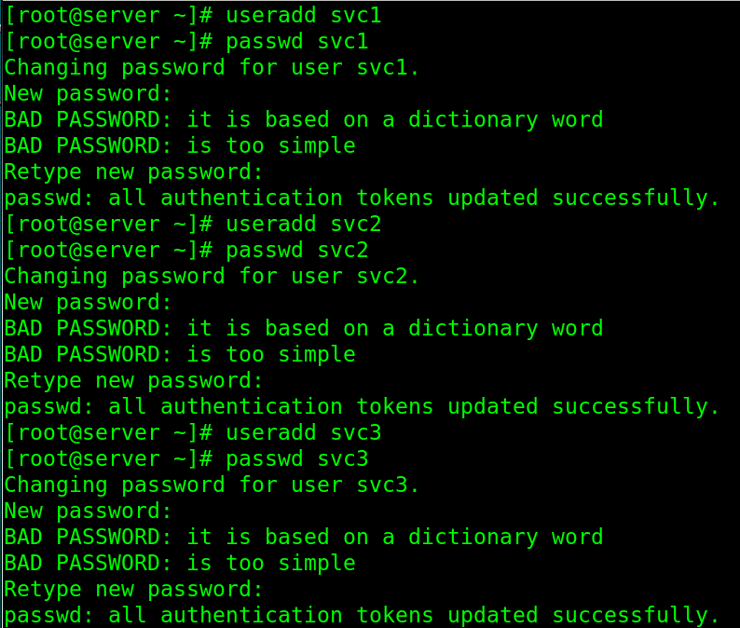
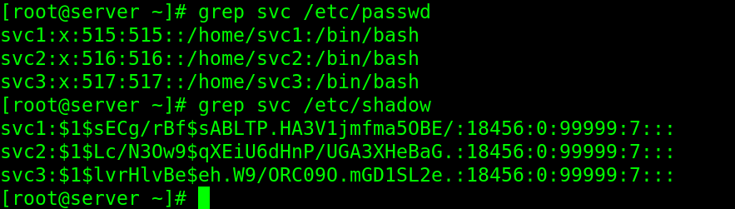

- They are in a group called servicedept. Create the group and add the users as its members. Display the group and the members.
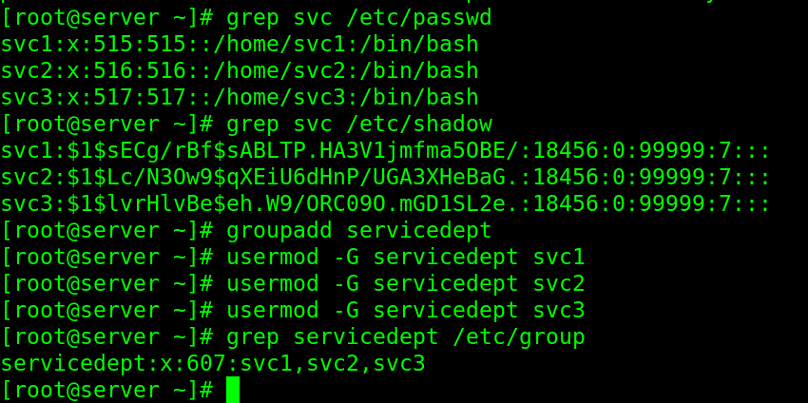

Or use cat /etc/group | grep <filter>

- Create the directory /home/contracts. Display the command and a listing of the directory.
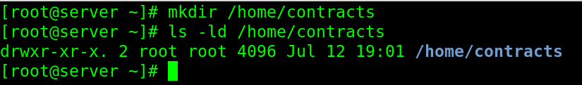

- Configure /home/contracts to be shared by servicedept group such that members can Read and Write to the shared directory. Display the commands and directory permission after configuration.
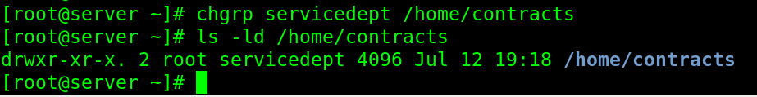
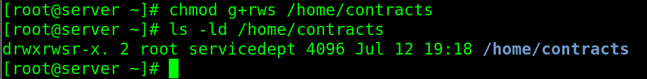
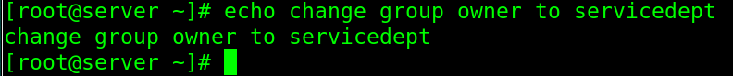

- Switch to svc1 user and show they he can create a file in the shared directory.
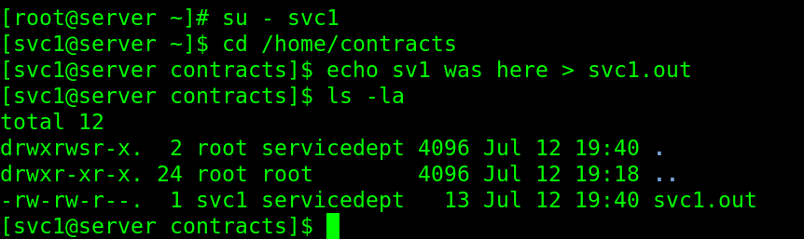

- Configure such that other users cannot see the directory or its contents (except root). After configuration, display the directory permission here.
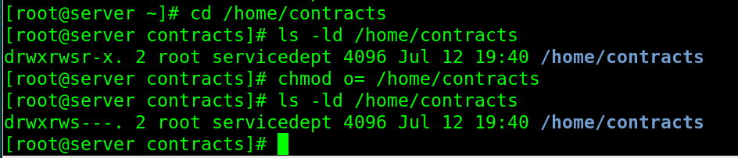

- Configure such that members cannot delete other members files. They can only delete their own files. Display your commands and list the shared directory permission after configuration.
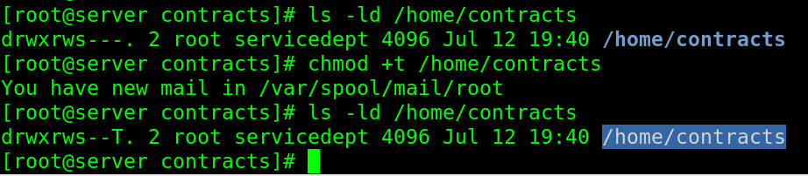

- Use ACL to enable a user alex (create the user if necessary) to have Read, Write and Execute permission to the shared directory. Display the command here.
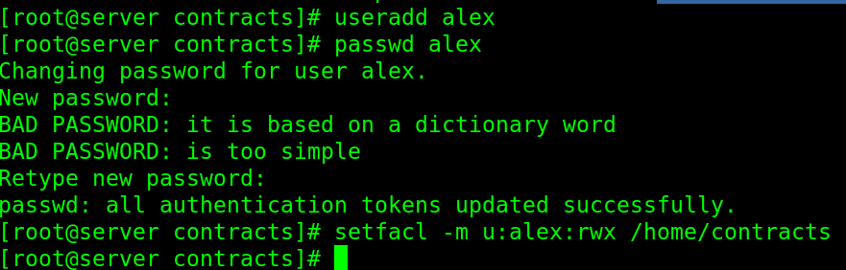

- Display the ACL permission of the shared directory here.
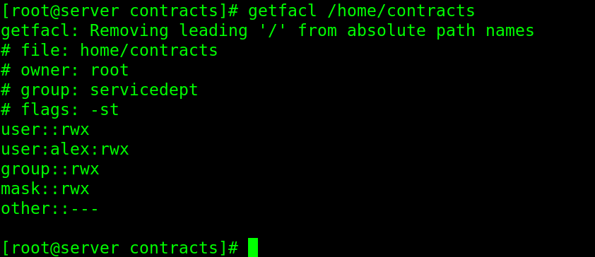

- Configure such that members can ONLY READ other members files. Members can edit or delete their own files but not other member files. Display your commands and some test results here. You may need to google this.
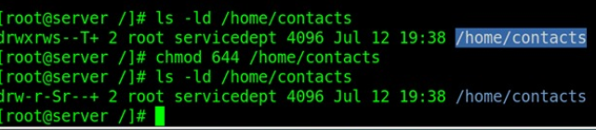

SHOULD BE SET AS 640 (DW OTHERS TO READ)

Task 2
Pre-requisite: In one of the practical, sales1 user was created. If you did not do it, create the user sales1 first before proceeding.

- Backup /home/sales1 directory to /tmp/sales1.tar
Display the command and a listing to show the archive file.
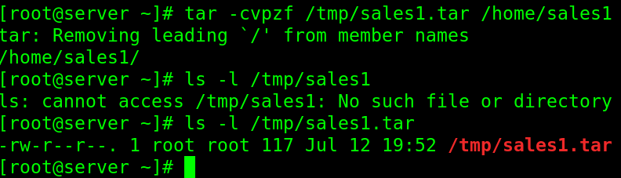

- Delete /home/sales1 completely. Display the command and show that /home/sales1 does not exist anymore.
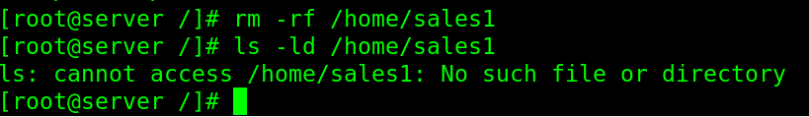

- Restore /home/sales1 from the archive /tmp/sales1.tar
Display the command and output.
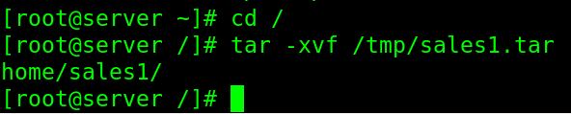

- Check that /home/sales1 has been restored. Show that sales1 has been restored.
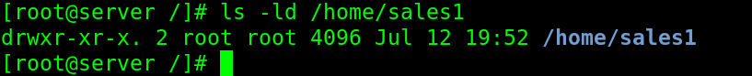

- Use rsync to backup the /home directory to /tmp/homebackup. Display the command below.
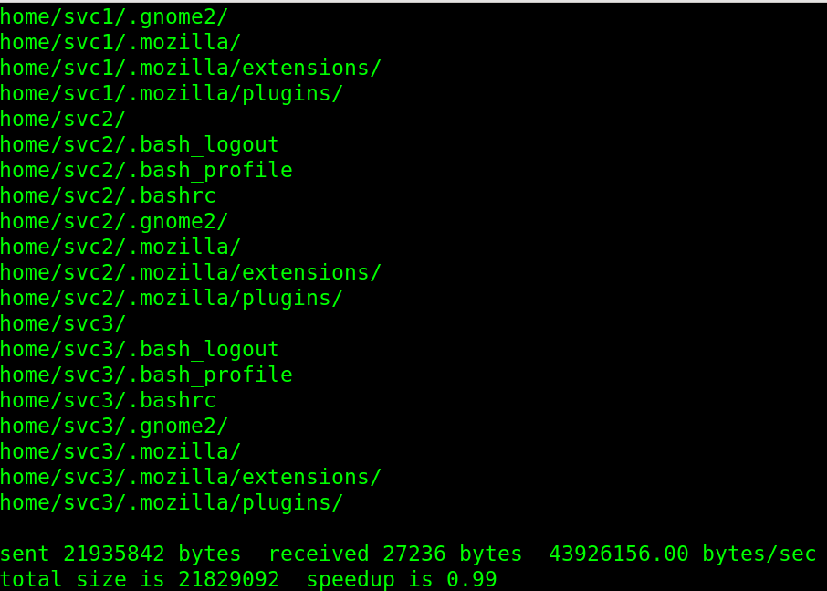

Save the file in PDF format and submit in Blackboard.

[The End]

